CarbonBridge

[CarbonBridge](https://carbonbridge.io/) is a pre-seed startup currently headquartered at the [HAX space in Newark](https://hax.co/). They convert methane waste gas to liquid methanol fuel via direct-gas bacterial fermentation. My responsibilities as a mechanical engineer have included bioreactor design, fluid control, temperature control, upstream and downstream process design, scaling planning, and miscellaneous engineering and experimentation support tasks.

# Bioreactor Design

## 5in filter diameter bioreactor

I designed, assisted with the manufacturing (but did not manufacture it myself), and assembled the bioreactor below. It ferments bacteria on a porous filter within the reactor, and has top and bottom ports for gas and liquid to pass through. I also designed the fluid controls, electronics, and experimental protocol used with the bioreactor.

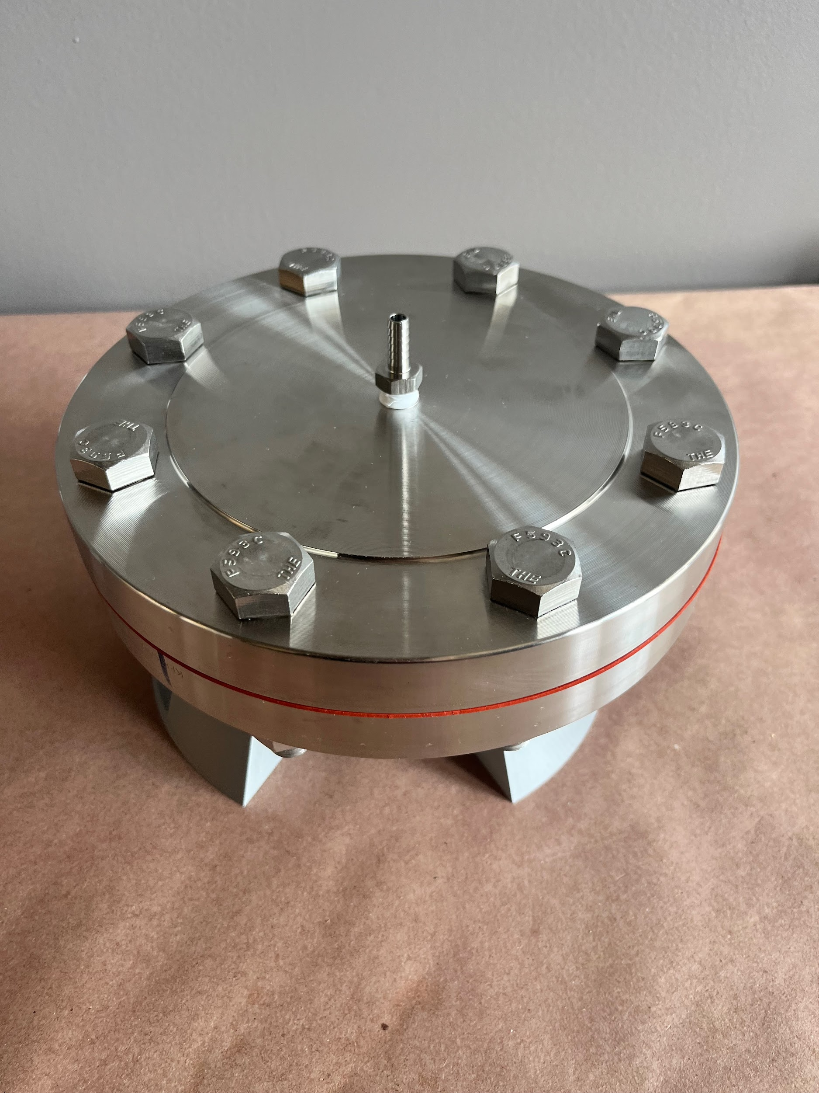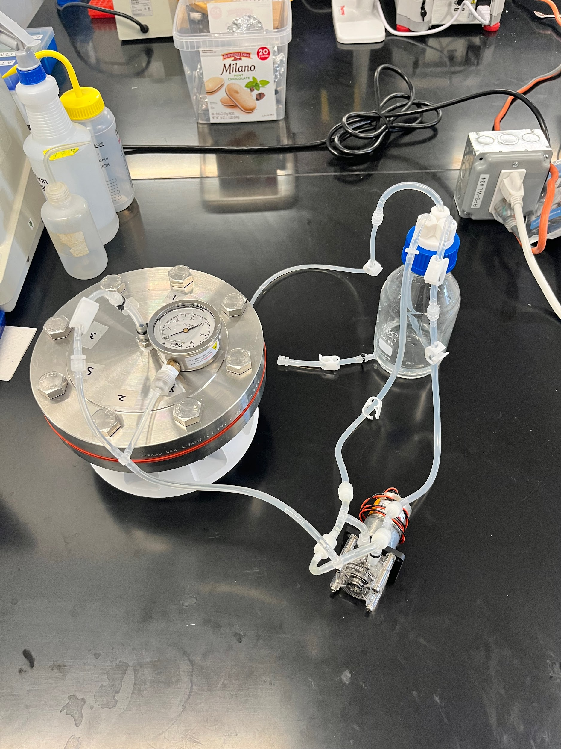

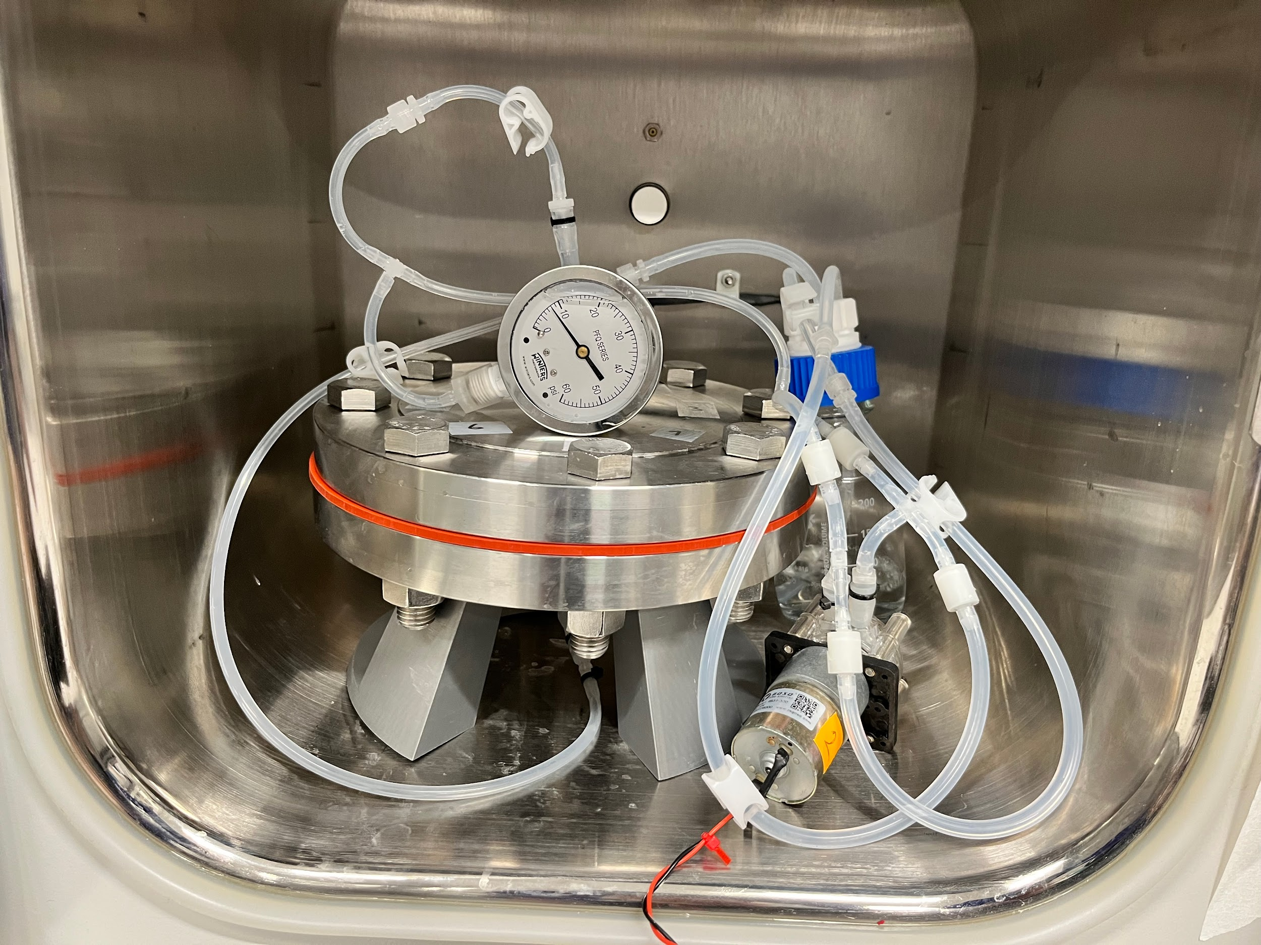

## 47mm filter diameter bioreactor

Below is a 47mm filter holder that we used for direct gas bacterial fermentation experiments. It is an off the shelf device that I selected to use in the experimental systems I designed.

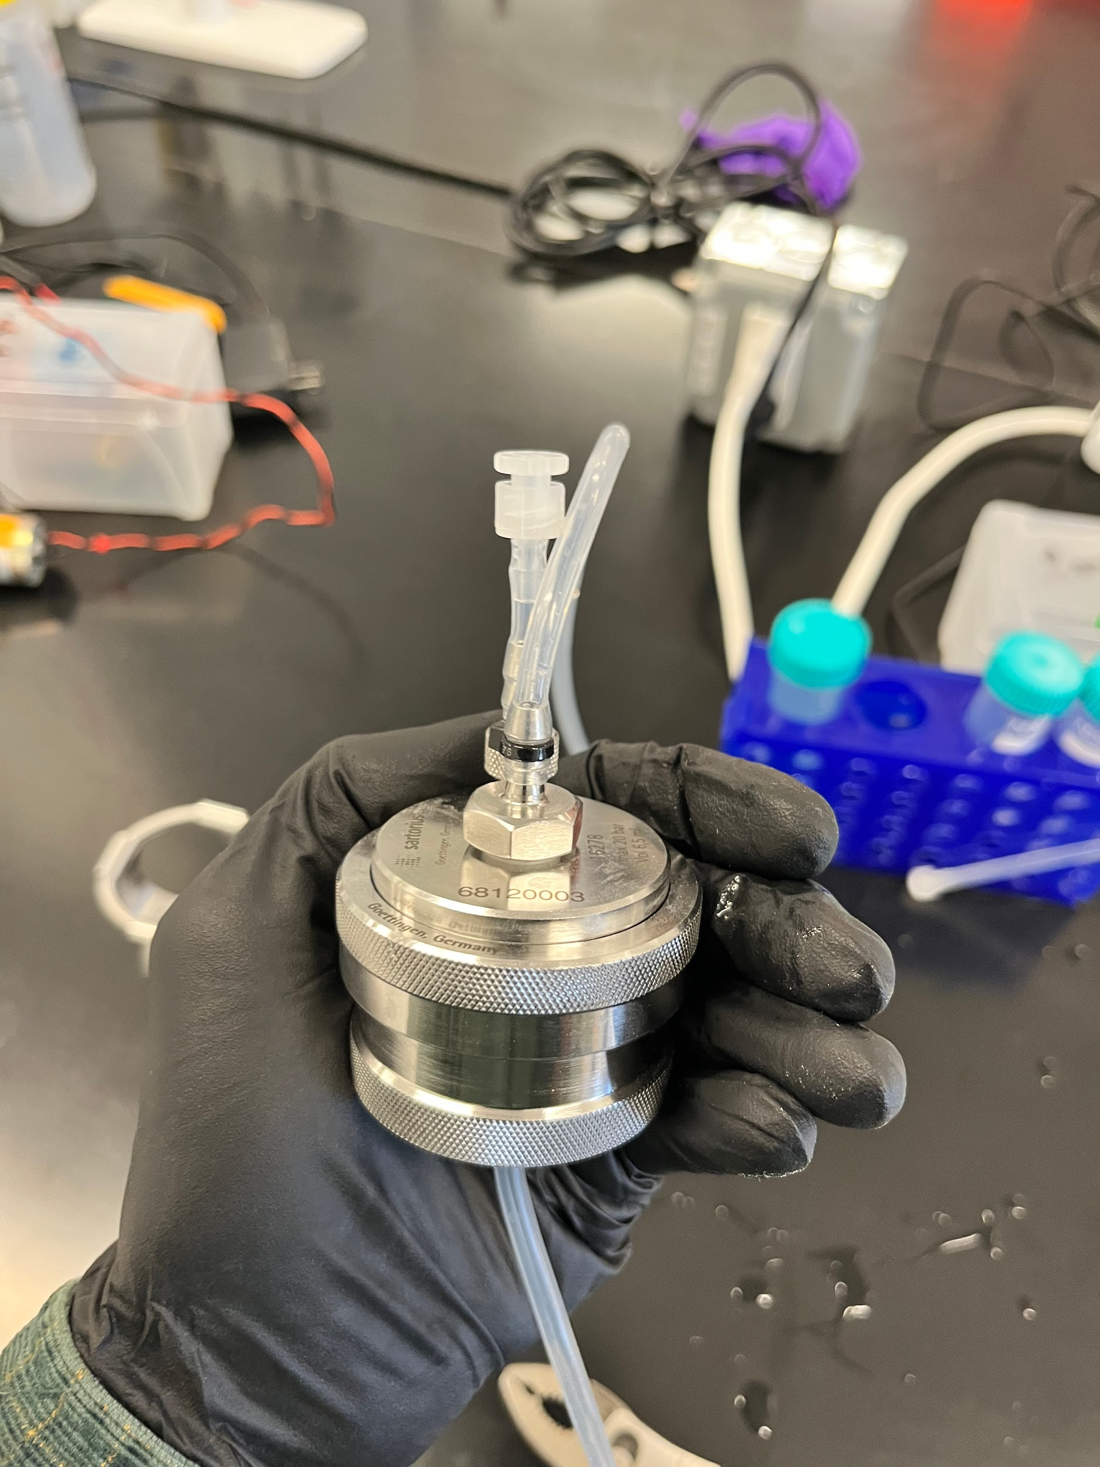

47mm filter in incubator with syringe pump:

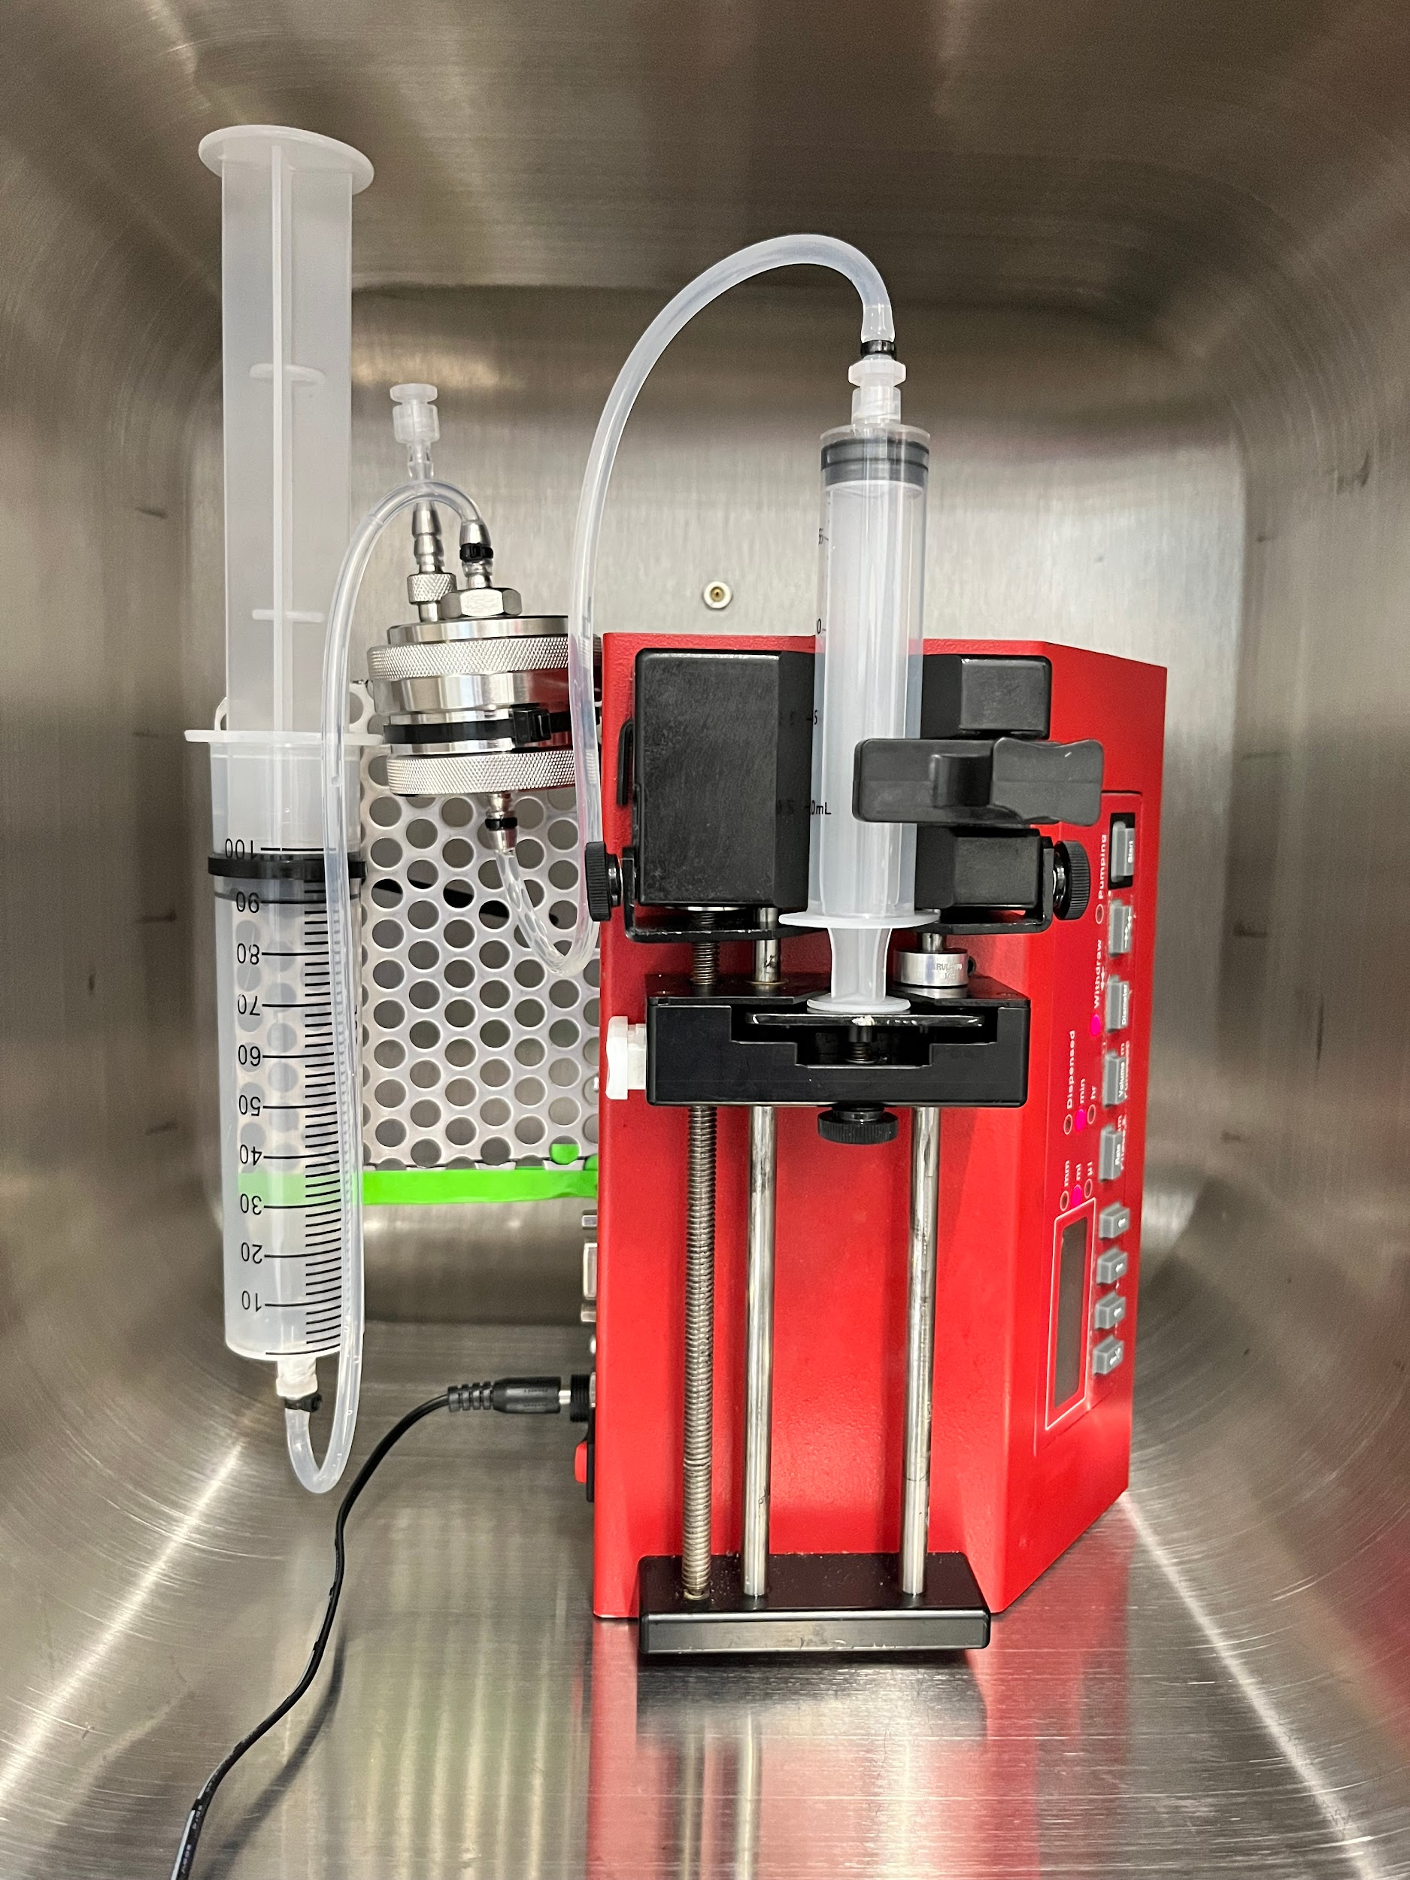

# Temperature Control

Below is a bioreactor temperature control system I designed and assembled:

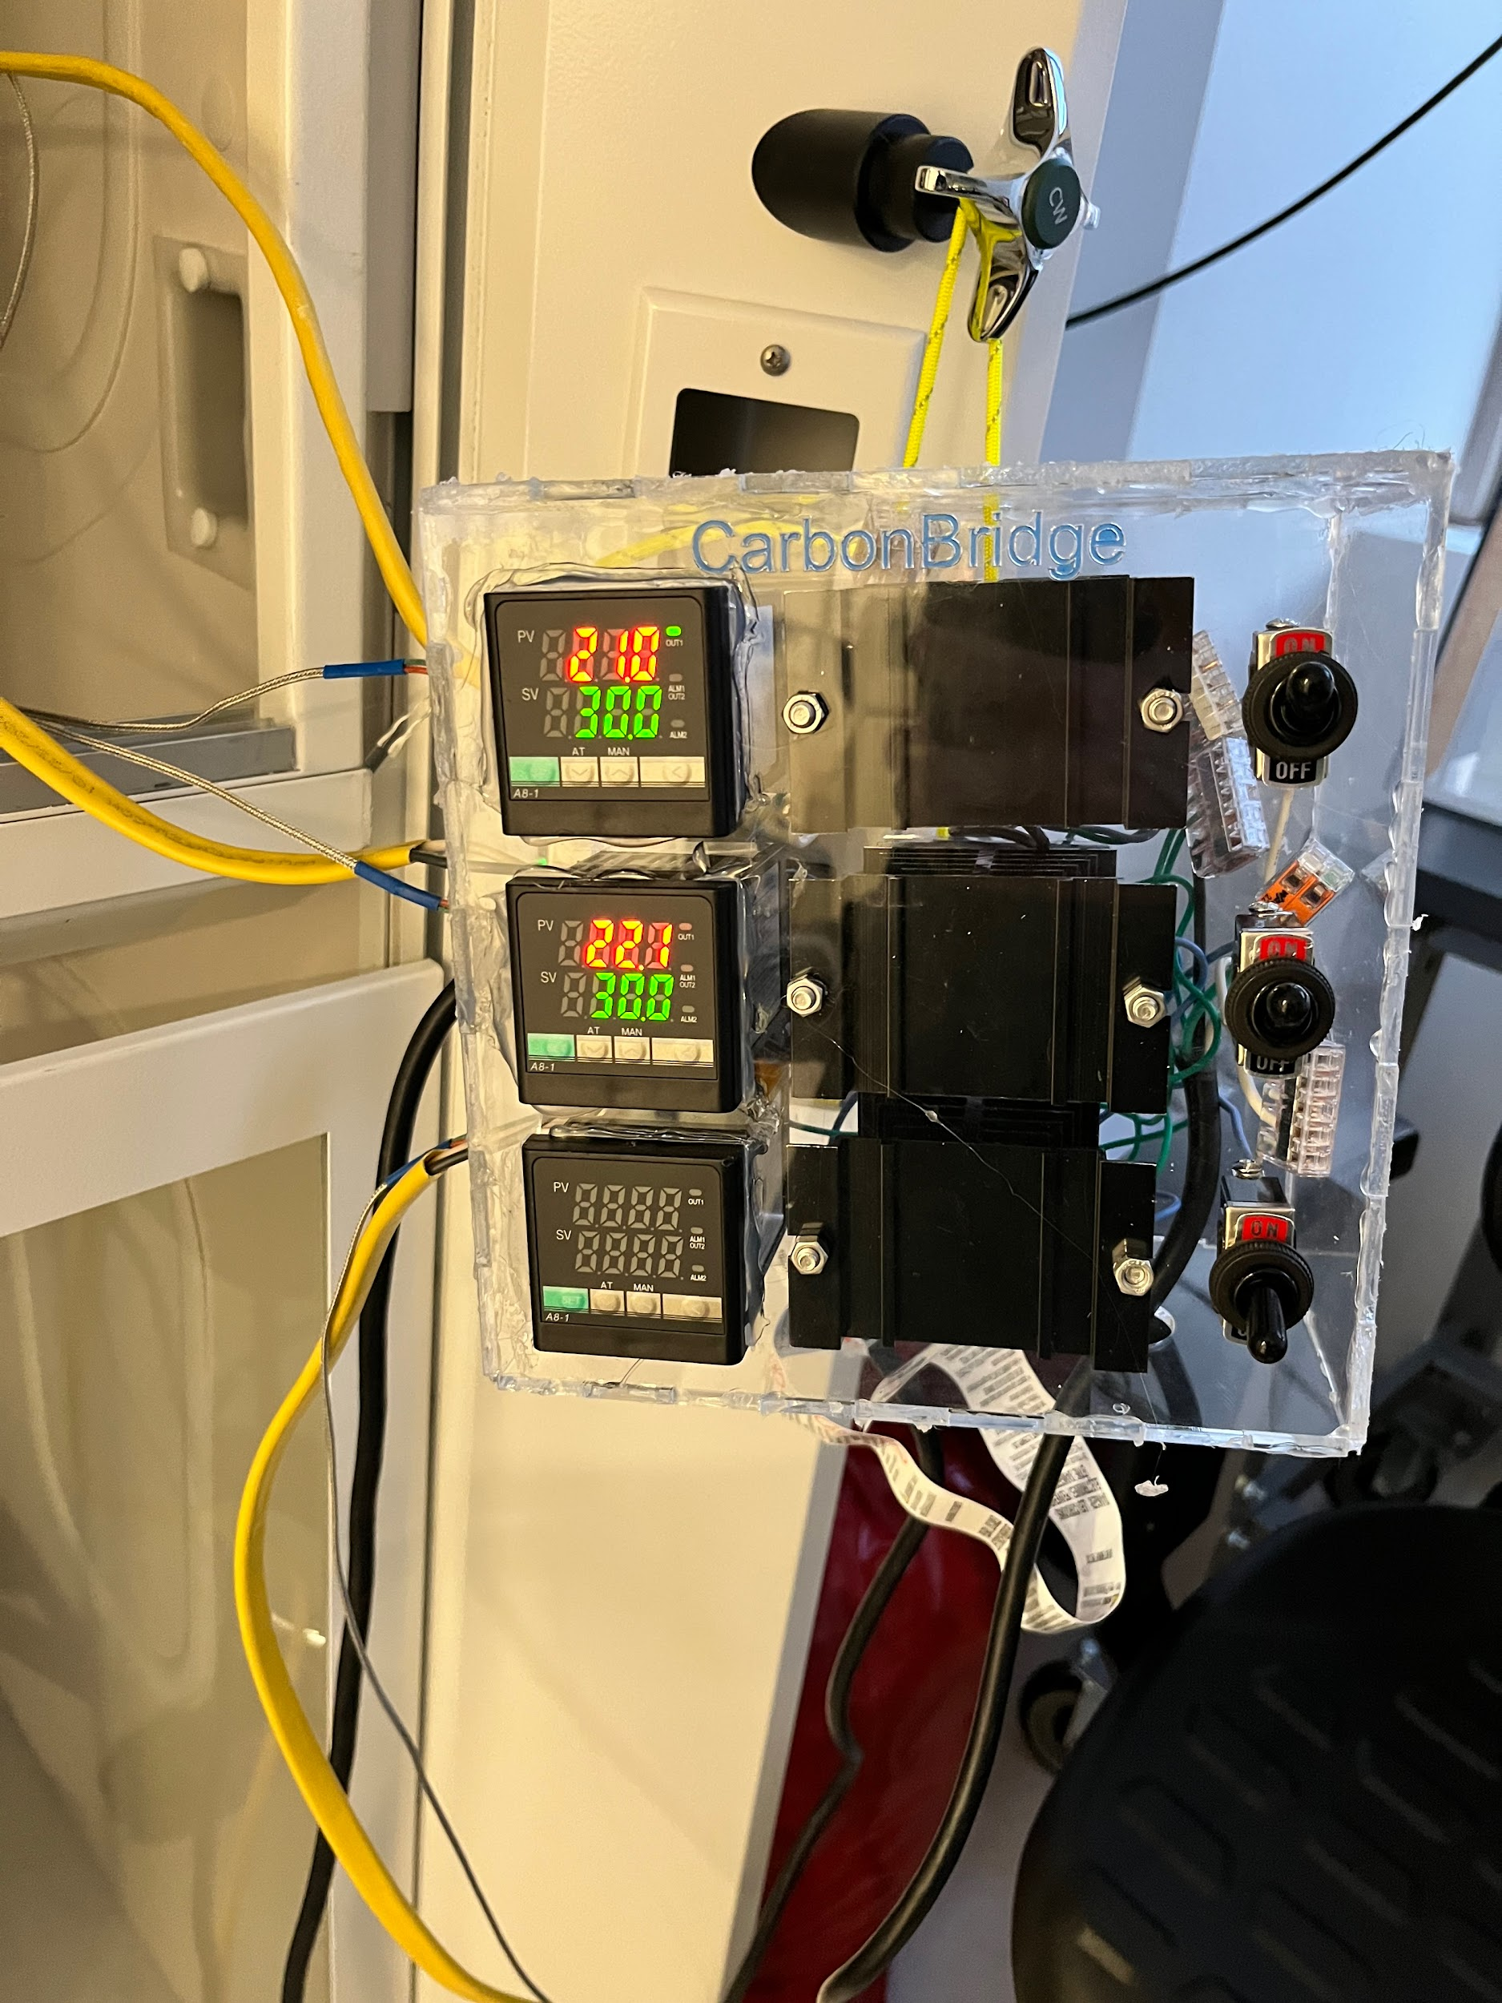

# Miscellaneous

Gas control system that the bio team and I used to conduct direct gas fermentation experiments. I disassembled this, moved it between labs, removed some parts to make it more space efficient, and reassembled it at our new lab. The original design and assembly were not my own.

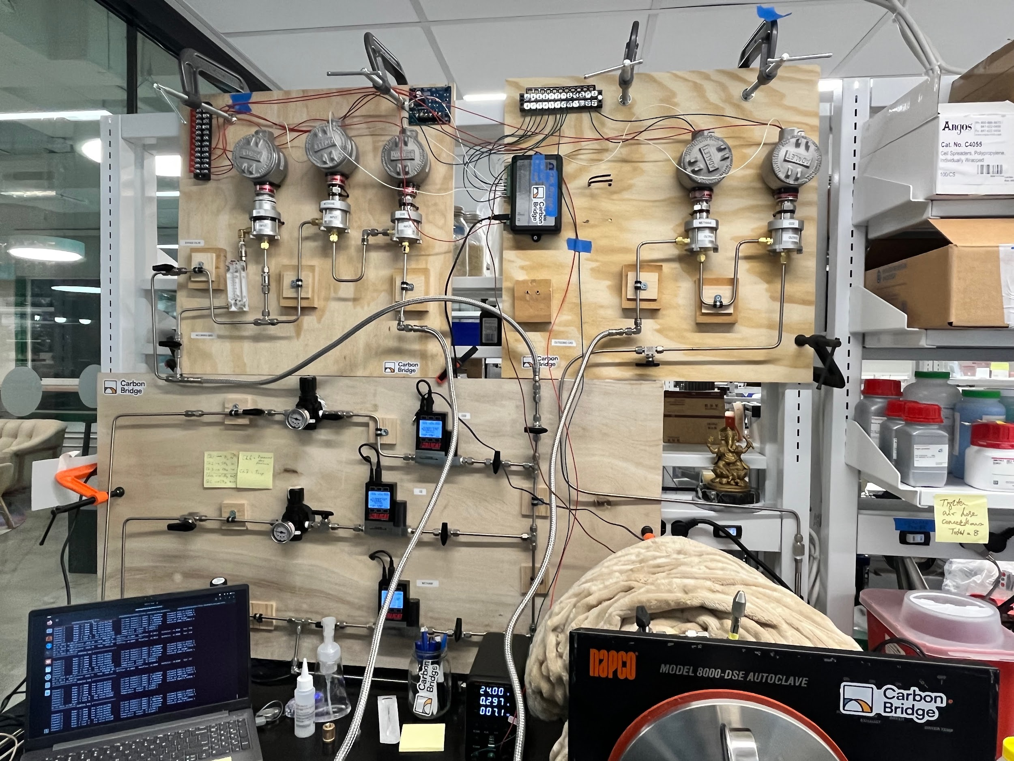

Early prototype reactor:

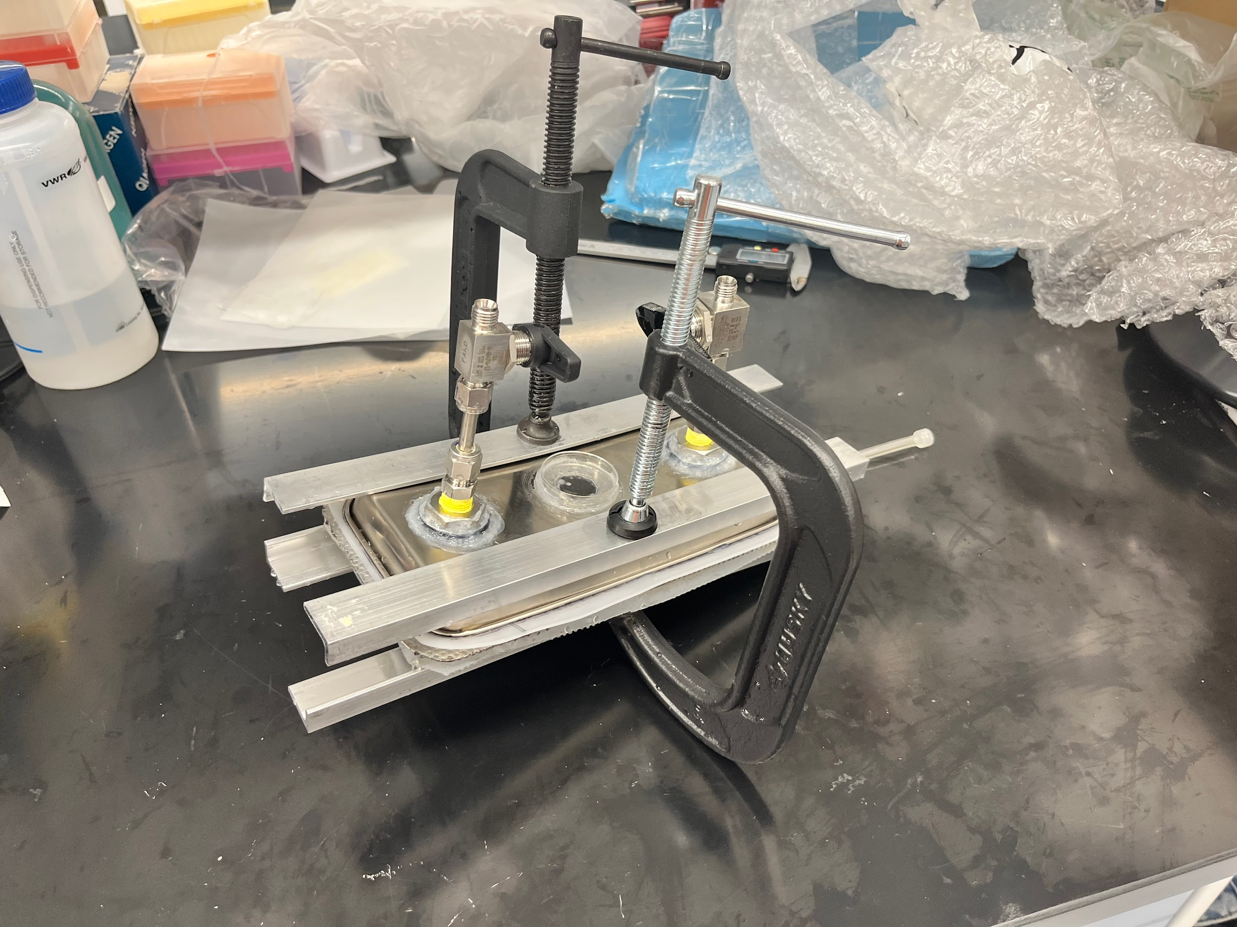

Custom 3D printed 1mL vial trays:

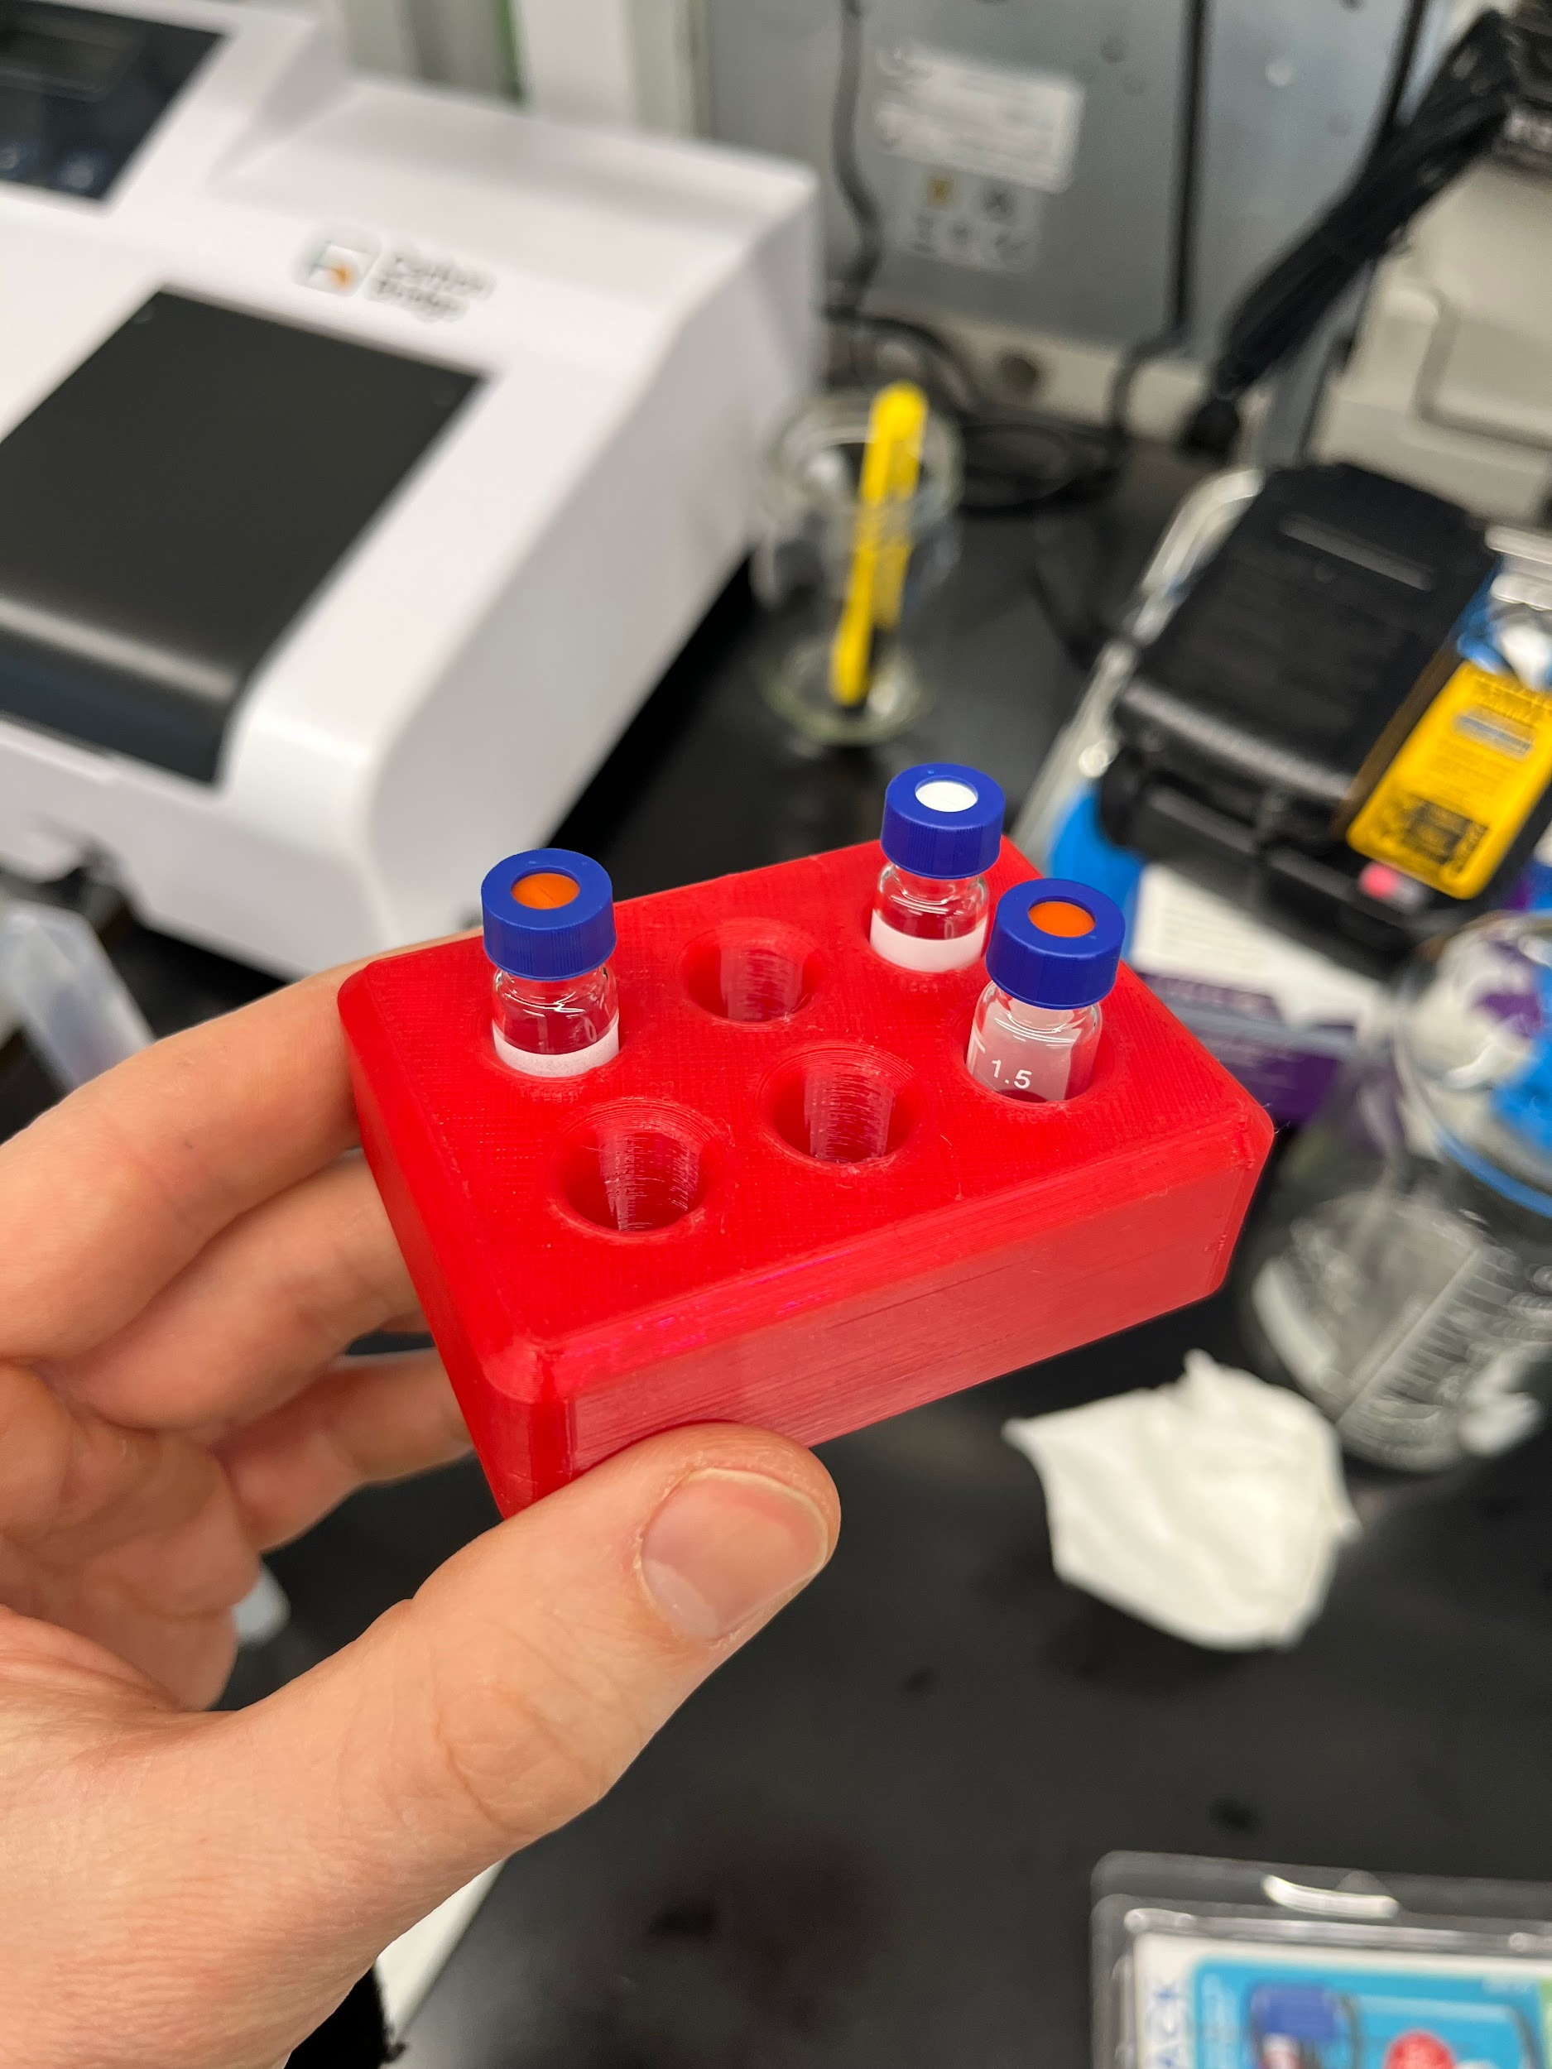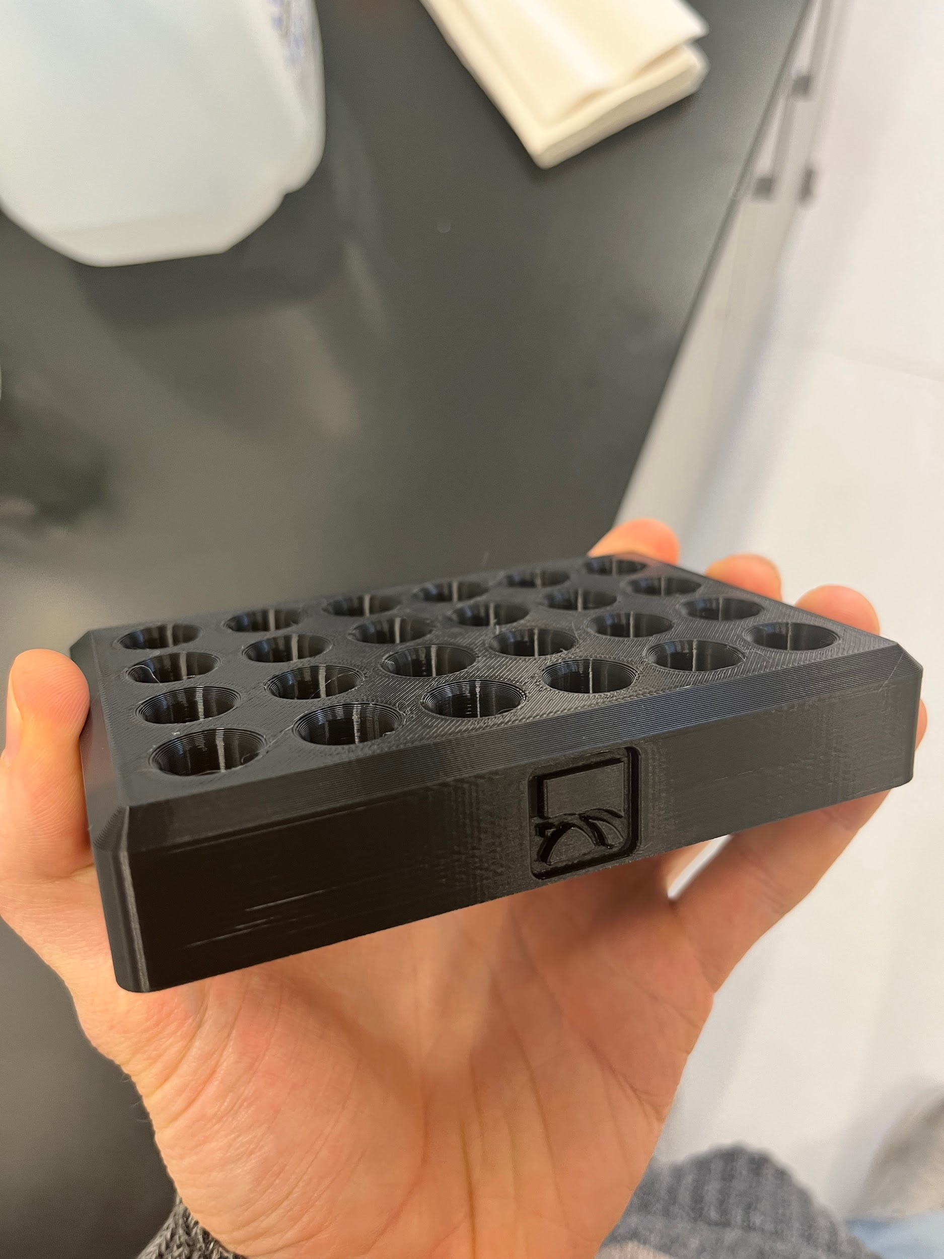

Indicator lights + housing on a bioreactor:

